**The Element Sign in is clicked**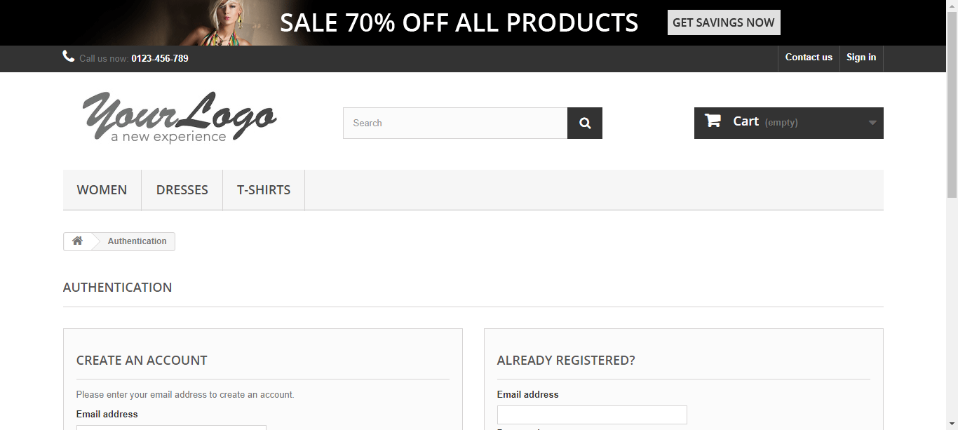

**The input Automation@americantech.com has been entered sucessfully**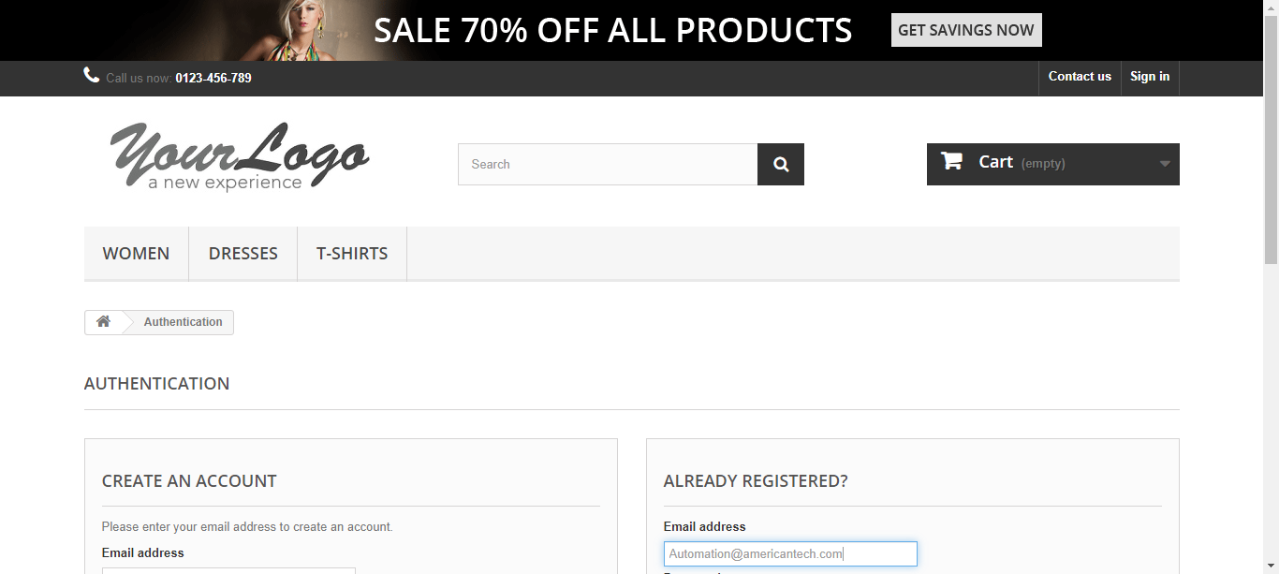

**The input Jan@2020 has been entered sucessfully**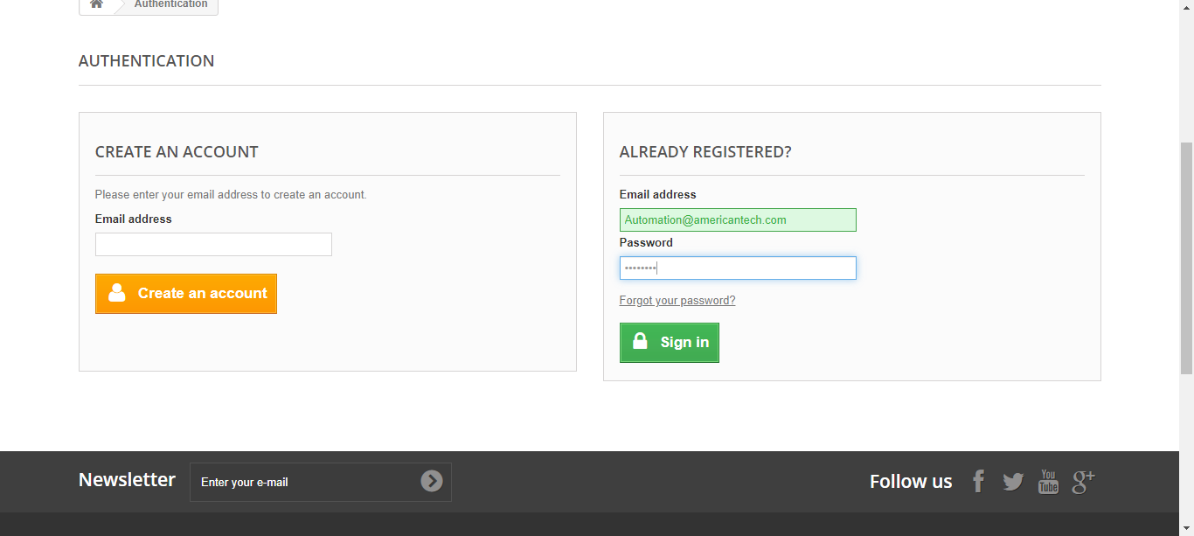

**The Element Sign in is clicked**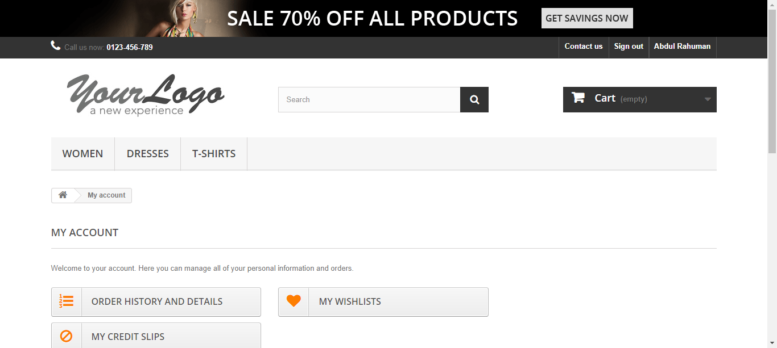

**The Element Abdul Rahuman is clicked**

**The Element ORDER HISTORY AND DETAILS is clicked**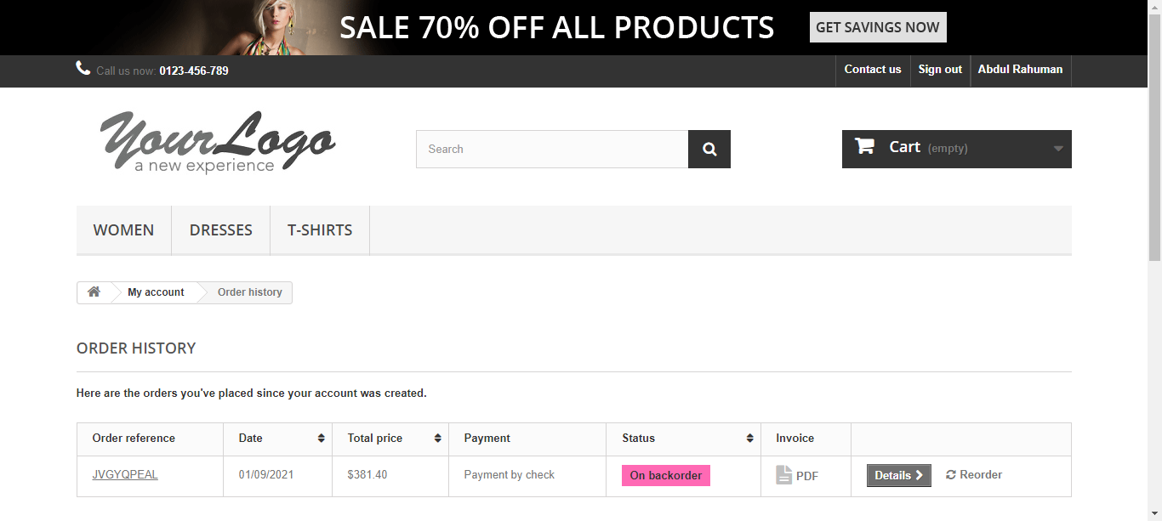

**The OrderSummary ScreenShot 1**

**The OrderSummary ScreenShot 2**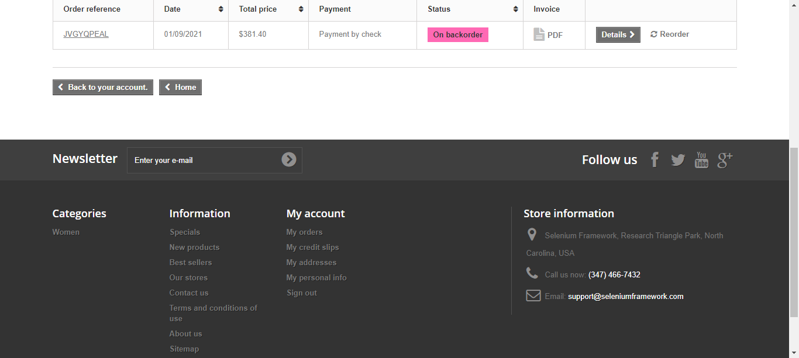

**The Element Sign out is clicked**